Examination User

OVERVIEW

As examination is an essential part of session therefore, examination user can schedule and conduct examination through ERP effectively and efficiently. Examination user needs to perform some activities to conduct examination such as grade criteria, evaluation, scheduling, and result declaration.

How to create exam master?

Exam master is used to define grades, grade criteria and evaluation component. Examination user has to create exam master for further activities related to examination.

- Grade Master- Grade master used to define the grades as shown in figure-1. To create grades following are the steps:-
- Click on “Add” button
- Enter grade name for e.g. A
- Set rank order
- Set grade points.
- Check the checkboxes according to grade.
- Click on “Save” button.

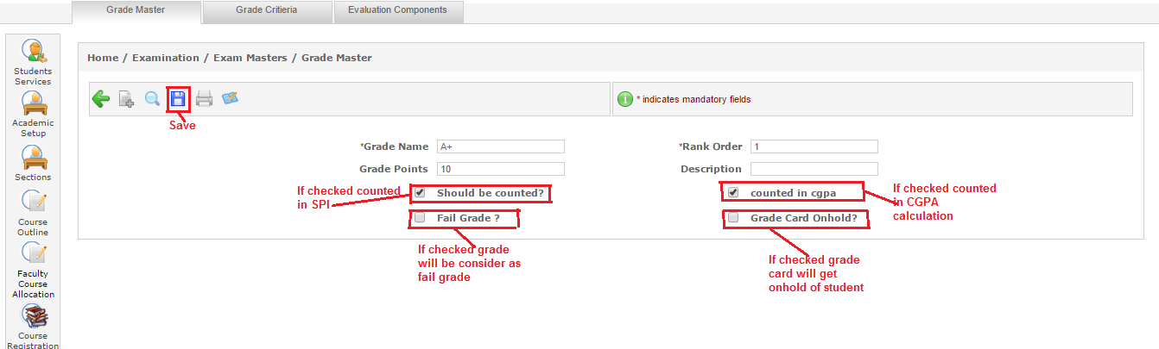
Figure-1

- Grade Criteria- It is used to set the criteria of grades. For e.g. “A” grade will be given when the percentage is in between 85 to 100 (shown in figure-2). For setting the grade criteria following are the steps:-
- Select admission year, program, term and course.
- Enter the “From Percentage” and “To percentage”. For e.g. 85 to 100(Shown in figure-2)
- Select the grade from drop down according to percentage.
- Click on “Add” button.
- Click on “Save” button.

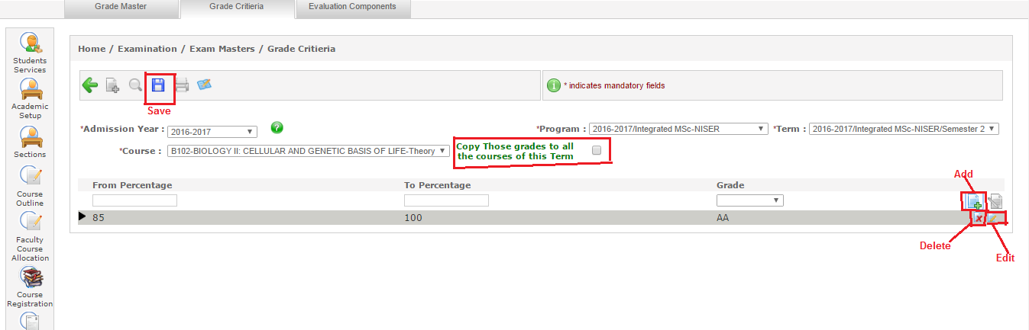
If this checkbox is checked then the grade criteria will be set to all courses of the selected term.
Figure-2

- Evaluation Component- It is set by the examination user (as shown in figure-3). It is used to define the course outline of the subjects. Parent component if required in the course outline can be selected by the user.
- Click on “Add” button.
- Select radio buttons. “Yes” if exam required or “No” if exam not required.
- Click on “Save” button.

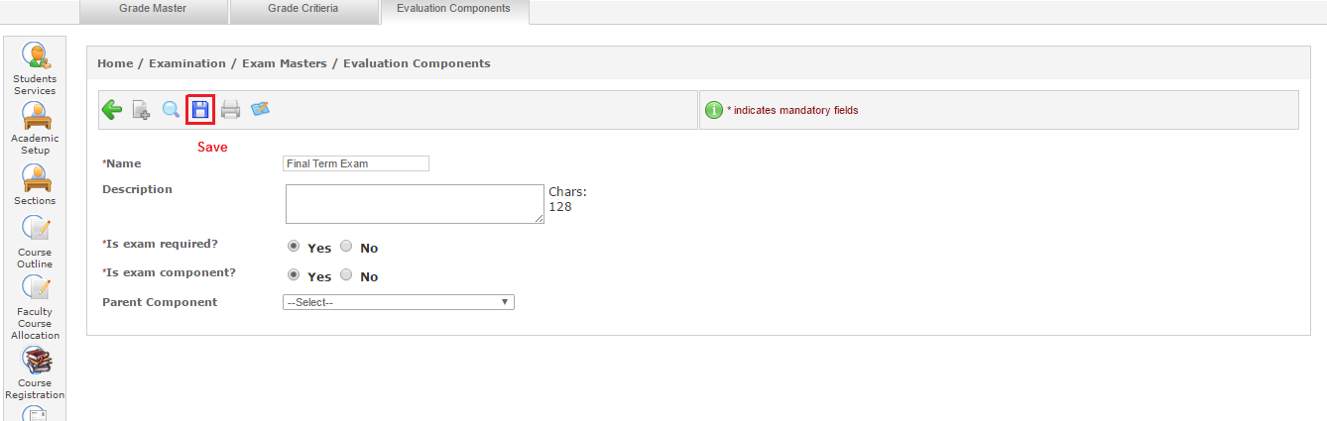
Figure-3

How to schedule examination?

Examination scheduling is an important part done by examination admin. When exam is to be conduct, exam registration, start and end date all needs to be defined by user.

- Exam Scheduling- It is used to define for which academic year and term, exams going to be conduct. Examination user can also define the exam start and end date, exam type etc (as shown in figure-4).
- Click on “Add” button.
- Select “Academic year” “program” and “term” from dropdown.
- Enter name of the examination.
- Select exam type.
- Enter exam start and end date.
- Select the authority that approved the exam from dropdown.
- Select the radio buttons according to the requirements(shown in figure-4)
- Select courses to be scheduled.
- Click on “Save” button.
If this checkbox is checked then reappear exams will also be include in this set up.
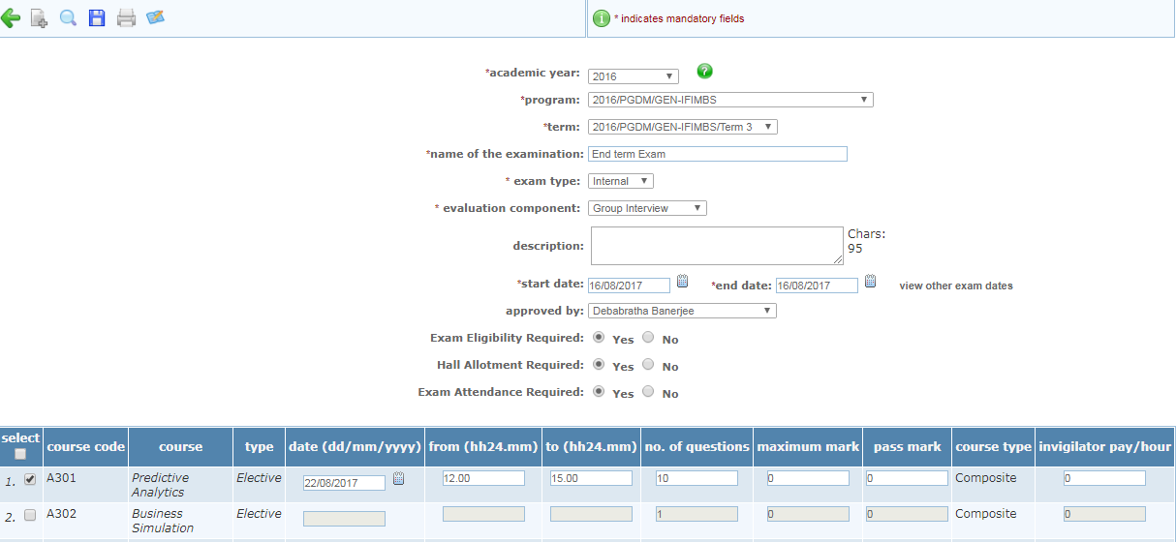
Figure-4

- Exam Time Table- It is used to schedule the exam slot-wise. As system schedule the exams slot wise automatically. System checks the clashes and schedules the exams. If there is any clash found then that course remain unscheduled and ask admin to schedule manually (as shown in figure-5).
- Select academic year, term, and examination.
- Select examination dates.
- Enter number of slots and student can be allocated to maximum slot in one day.
- Select class type.
- Select course to be scheduled and not to be scheduled.
- Click on “Go” button.
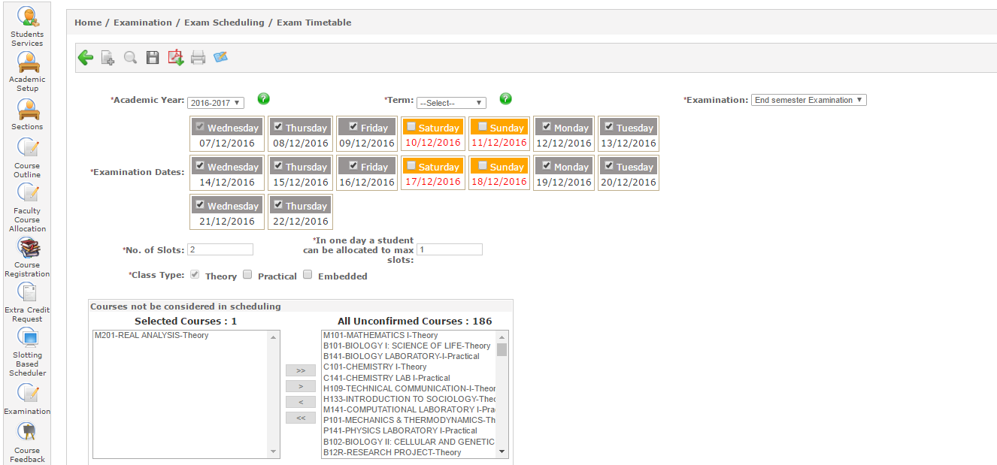
Figure-5

- Exam Eligibility- It is used to identify the students who are eligible for examination on the basis of attendance or fees.
There are three types of eligibility admin can set.
- By Cumulative Attendance-
- Select admission year, course, semester and examination.
- Select “by cumulative attendance”.
- Enter attendance percentage and click on “Go” button.
- Students list appear on screen that have the required percentage (as shown in figure-6).
- Click on “Save” button.
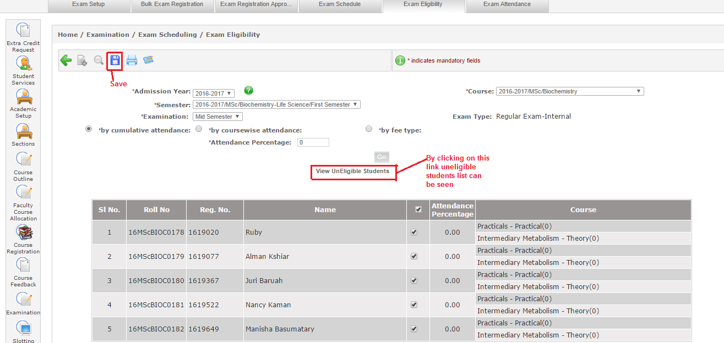
Figure-6

- By coursewise attendance-
- Select admission year, course, semester and examination.
- Select “by coursewise attendance”
- Select course from dropdown.
- Enter attendance percentage and click on “Go” button.
- Students list will appear according to the attendance criteria (as shown in figure-7).
- Click on “Save” button.

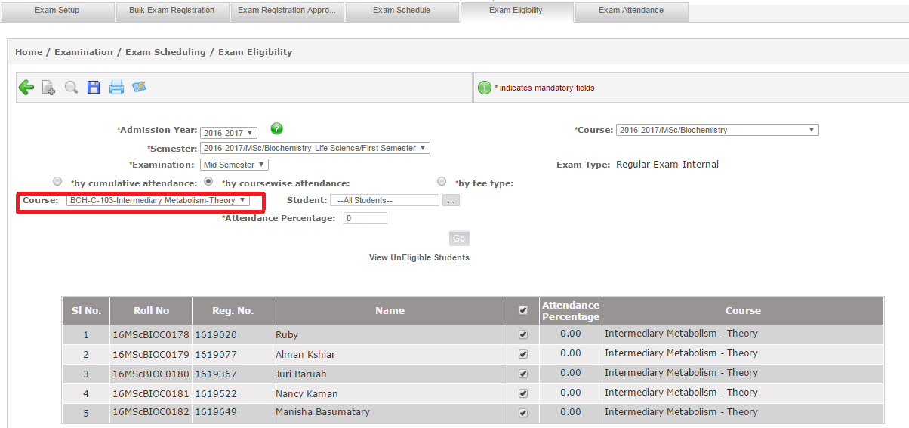
Figure-7
- By Fee Type-
- Select admission year, course, semester and examination.
- Select “by fee type” radio button.
- Select fee type from drop down and click on “Go” button (as shown in figure-8).
- Student list will appear on screen. Select students and click on “Save” button.
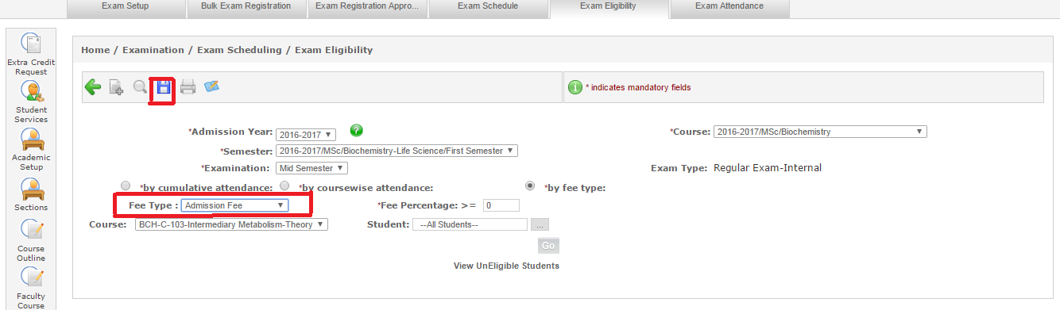
Figure-8

- Exam Attendance- Exam attendance is required when it is selected while setting up the exam under Exam Setup. Admin can take attendance by following below steps (as shown in figure-9)
- Select admission year, course, semester, examination, course and venue.
- Select status of student as present, absent or detain.
- Enter number of main sheet and supplements.
- Click on “Save” button.

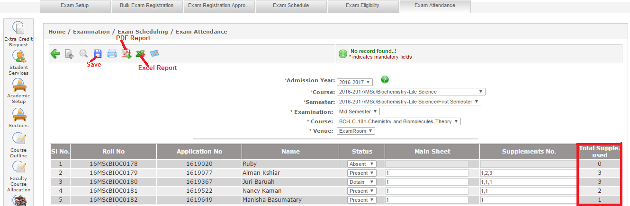

Figure-9

How to evaluate examination?
Exam evaluation is used to define the course outline, exam marks entry, grade entry, mark sheets etc. which is a necessary part of examination.

- Course Outline- Course outline is used to define the maximum marks and weightage of the course. Here it can also be defined whether exam is required for the course or not. Course outline has to be created for each and every subject individually which are running currently in the syllabus. To create course outline following are the steps (as shown in figure-10)
- Click on “Add” button.
- Select admission year, term, subject, and faculty.
- Check the checkbox of section.
- Enter start and end date for conducting the examination.
- Select evaluation component.
- Enter maximum marks and weightage and check the checkbox if exam required for the course.
- Click on “Save” button.

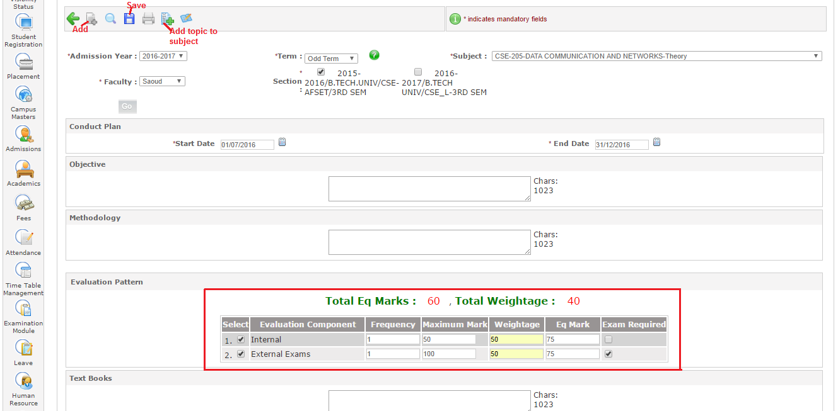
Figure-10

- Component-wise Marks Entry- It is used to enter the marks in the components defined in evaluation component. Marks to be entered will be according to the defined course outline of subjects. This is used to enter marks of internal assessment or for those subjects for which examination is not required. Admin can enter the marks by follow these steps:-
- Select academic year, term, course, class and faculty (as shown in figure-11).
- Click on “Go” button.
- Check the checkbox for selecting students.
- Enter the marks and click on “Save” button.

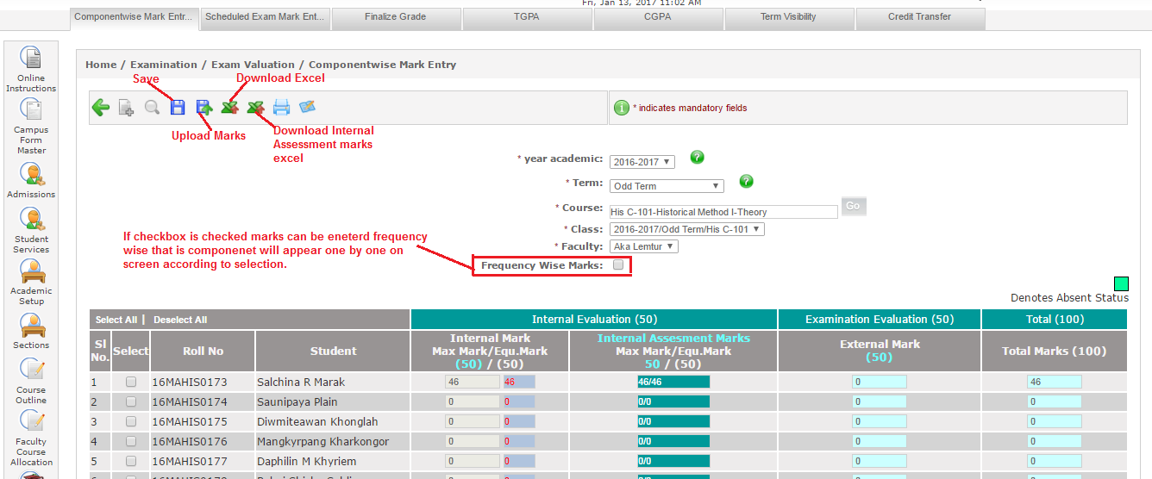
Figure-11

- Scheduled Exam Marks Entry- Scheduled exam marks entry to be done by admin for the component which required examination. Marks entry will be according to the defined course outline. These marks also reflect in component wise marks entry. Following are the steps to enter marks:-
- Select academic year, term, examination and course (as shown in figure-12).
- Select regular or reappear.
- Enter marks and click on “Save” button.

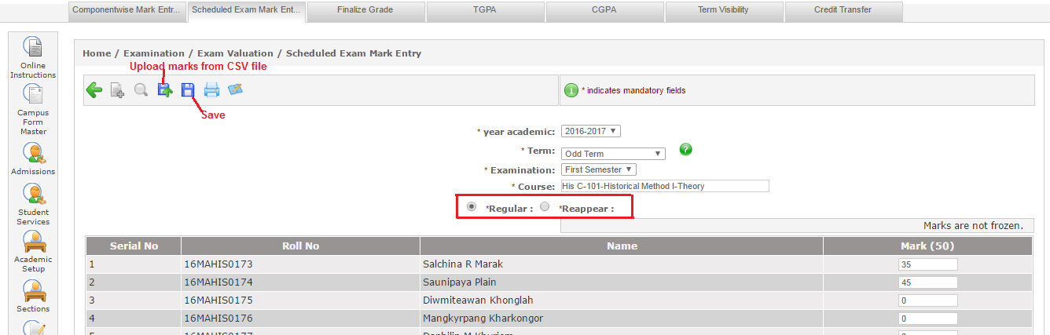
Figure-12

- Finalize Grades from Admin Portal- Finalize grades is used to enter the grades according to the marks scored by the students. Admin enter the grades according to the scores/marks. Following are the steps of entering the grades from admin portal:-
- Select academic year, term and course (as shown in figure-13).
- Click on “Go” button.
- Enter the initial and final grades. Initial grades can be copied to final grades through “Copy Grades” button.
- For saving the grades click on “Save”.
- For freezing the grades click on “Freeze Grades” button.
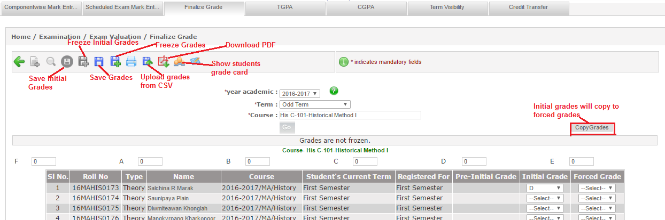
Figure-13

- GPA - GPA is calculated on the basis of grades allotted to the students. It is to be calculated when all the grades of the batch get frozen. Following are the steps to calculate GPA
- Select admission year, program and term (as shown in figure-14).
- Click on “Calculate” button for calculating the GPA.
- Click on “Go” button for the list of students with calculated GPA.

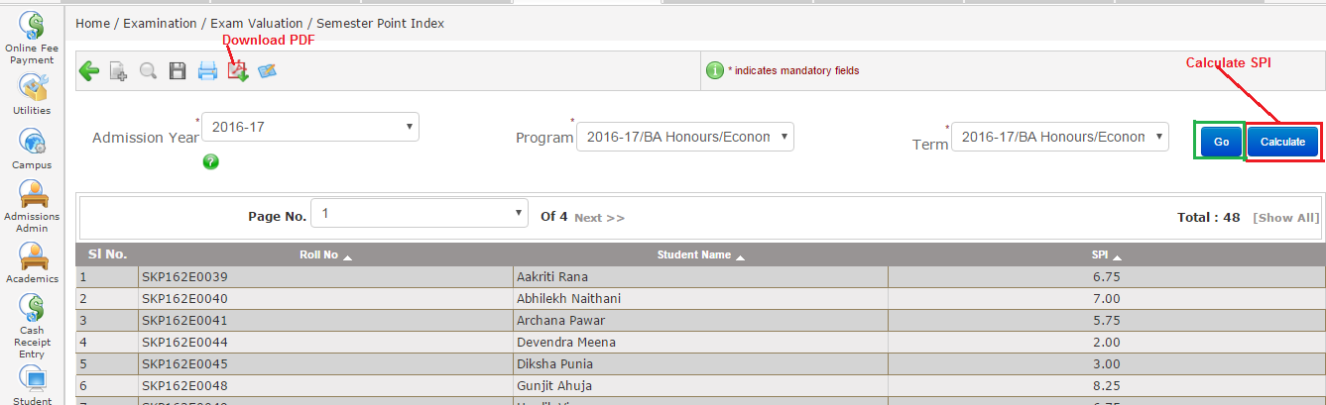
Figure-14

- CGPA – CGPA is calculated on the basis of grades allotted to the students. It is to be calculated after GPA calculation. Following are the steps of CGPA calculation:-
- Select admission year, program and term (as shown in figure -15).
- Click on “Calculate” button to calculate the CGPA.
- Click on “Go” button for list of calculated CGPA.
- Click on “Result Declare” to publish the result.

After publishing the result, result will show to students at result portal. But result declaration date also be entered in academic batch term otherwise result will not show to students.
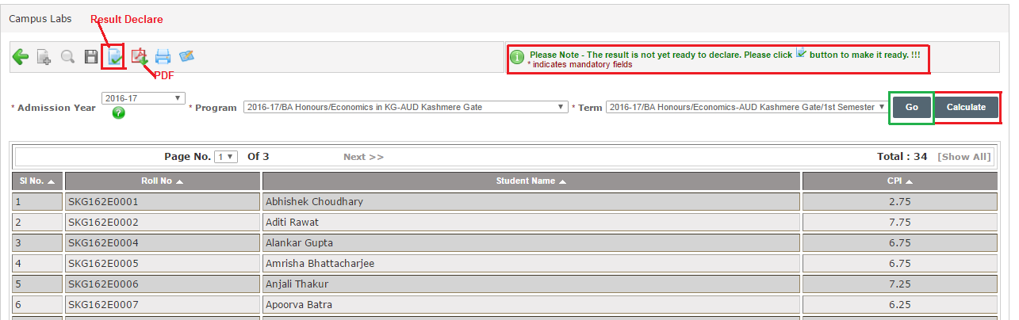
Figure-16

- Transfer Credits- Transfer credits is used to transfer the credits or grades of student from one term to another if needed due to some reasons. Following are the steps to transfer the credits:-
- Select admission year, program, term and student in credit transfer form (as shown in figure-17).
- Select admission year, program and to term in credit transfer to (as shown in figure-17).
- Click on “Go” button.
- Check the checkbox of course whose credits to be transferred.
- Select transferred course from drop down.
- Click on “Transfer Credits” if only credits need to be transferred.
- Click on “Transfer Credits and Grades” if credits and grades both needs to be transferred.

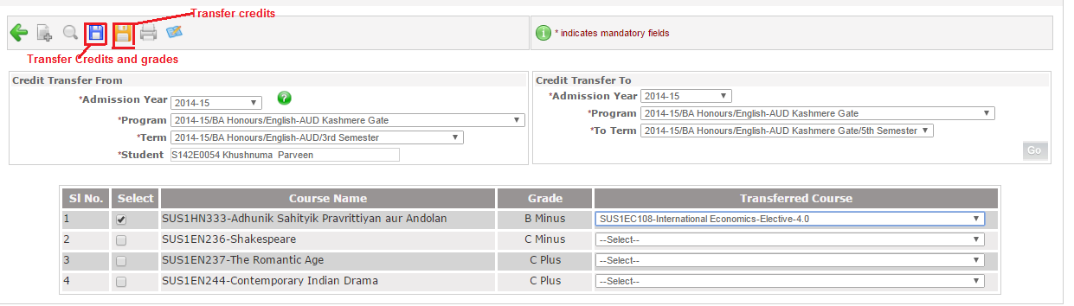
Figure-18

- New Term Promotion: - After successful completion of semester or year of academics, student get promotion to next term. From new term promotion screen, admin can promote or demote the students.
- Select admission year, program and term (as shown in figure-19).
- Select new term in which the student gets promotion or demotion.
- Select students and click on “Save” button.
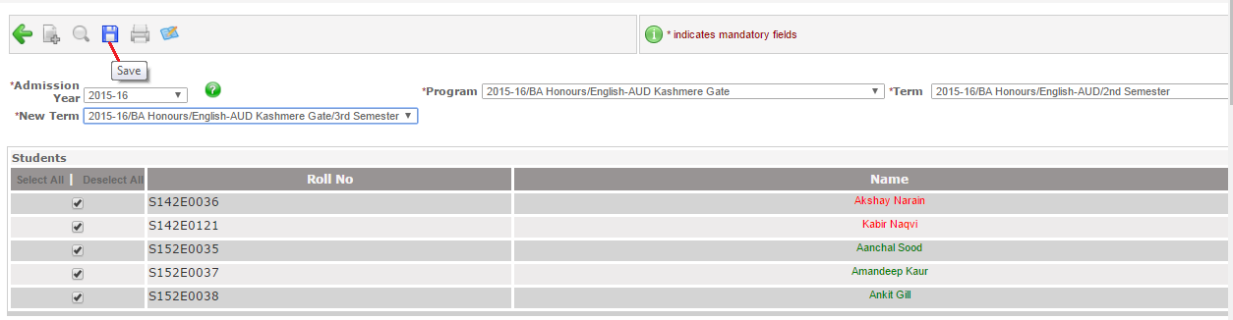
Figure-19

